

SensorShare v0.5

By Sam Bailey
Developed for Sensing4U
2025

Introduction
SensorShare is a sensor data view application that has been developed for the company Sensing4U. It has been built to load and display datasets in a readable format for analysis.
It was created as a Windows Forms Application, written in C#, displaying the data within a 2D DataGridView. The user can search the dataset for a value, view clear data bounds through cell shading, and order the data via the column values.
It can currently load multiple datasets via stored and paired binary and JSON files, save datasets in the same format, and allows the user to easily navigate between these datasets within the application window.
This version of SensorShare represents a Minimum Viable Product, allowing it to be rapidly iterated in future for additional features.

Sdlc (Iterative)
This application was created via an iterative software development life cycle, which is used for fast turnaround and allows for continual addition of future upon future iterations. For version 1, we narrowed in on the essentials of the needed application to allow us to demonstrate the potential product to our client within a small timeframe.
The features decided upon for our first iteration were saving, loading, and viewing of the data.
We started our process by outlining these goals with the requirements set, specifically the requested singleton data processing class. Knowing that we needed this class to actually hold the methods for these decided actions, we worked on that first. A SensorData data model class was created to hold these values along with the requested calculated average value. This would allow all relevant data needed for a dataset to be passed between operations in one object.
We quickly found that adding generated metadata to the mock binary data itself and parsing it into this class was becoming too complicated for our simple first iteration. Therefore, we decided to create JSON files to hold the mock data metadata. This was passed into a Metadata class that the SensorData class then held.
This allowed us to finish the data processor and quickly work on our DataView UI handling class, then our middleware class, the DataController. The features were created through small cycles of implementation, testing, and refinement. This was broken up only by small areas of integration testing to ensure our classes were interacting as hoped.
Within our next iteration, we will be looking to add data sharing and a timeseries database that can help with loading larger datasets involving long spans of data collected over time.

Requirements
The requirements given to us in our brief were as follows

Functional Requirements
- Must be able to save data as binary files
- Must be able to load data from binary files
- Data must be loaded onto a 2D Grid
- Must display given bounds on the grid via cell colour shading
  - Blue must represent values below the bounds
  - Green must represent values within the bounds
  - Red must represent values above the bounds
- Calculate the average of the given data and display it.
- Search the dataset with a custom binary search.
- Must be able to load multiple datasets and navigate between them.
- Data must be sorted before searching
NON-FUNCTIONAL Requirements
- All calculations and data processing operations must be done by a singleton data processing class.
- Users must receive feedback when an error occurs, or a valid action occurs.
- Data must be stored in an ordered collection

Implemented Features
In addition to the requirements being included in this version of the application, some small quality of life additions were made to keep it easy to use.
- A method to calculate the standard variance for the implementation of default bounds.
- The search function was tweaked to return the closest match and variance from the search input. The DataController class then recieved the input and decided if it was an exact, close or no match for displaying.
- A simple clear bounds function to return the grid to its original appearance.
- The ability to save metadata as a JSON object alongside the binary file for easier loading later.
- A button disabling logic system to reduce null value errors being sent before data loading

How-To
Application Index
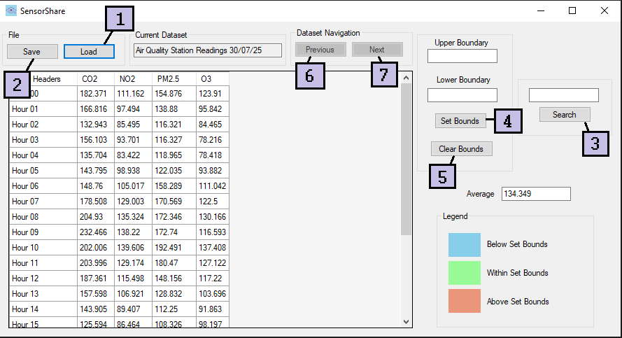
- Load Button
- Press the button. An Open File Window will open.
- Choose the JSON metadata file of the data you want to view
- The file will be displayed, and you will be ready to analyze.
Note (Don’t worry, the matching binary file will be loaded with it)
Note (The file will be loaded into an ordered collection, think of it like a list from left to right. It will be inserted in the rightmost position. All loaded files can be navigated to via the buttons in the Dataset Navigation box.)

- Save Button
- Press the button and a Save File Window will open.
- Choose where you would like to save the file
- Name the file in the input above the save button.
- Two files will be saved to that location, using the same name. One JSON with your metadata and one binary file.

- Search Button
- In the search input box above the button, type in the value you would like to find
- Press the Search Button
- A message will show you if a match was found and how close it was to your value.
- The cell within the DataGrid that holds your match will be highlighted.
See the Search result messages below
Match was Found | The number was located, and the difference was within the decimal place
Close Match was Found | The closest number to your search, within standard variation, was found.
No Match was Found | The number you searched for was not close to any value.
Note (If you click the button without a valid number, an error message with appear)

- Set Bounds Button
This Button can be used in a variety of ways. See Below.
Inputting a Lower and an Upper Bound
- Within the upper boundary input and lower boundary input, type the values you wish to set.
- Press the button and the bounds will be visually displayed upon the grid by coloring each individual cell.
- Here is a legend for what each colour means
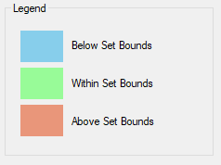

Inputting only a Lower or Upper Bound
- This button is still usable if you only wish to set one bound.
- Type the value you wish for either the lower or upper boundary input.
- Leave the other input blank.
- When you press the button, the grid will be colored in only two colors.
- If you set an upper boundary, the numbers above that boundary will be red, and numbers below it will be green
- If you set a lower boundary, the numbers below that boundary will be blue, and numbers above it will be green.
Leaving the Bounds blank
- If you press the button while both inputs are left blank, default bounds will be calculated using the average +/- the standard variance of the dataset.
- The cells will be colored according to these bounds, and the inputs above the button will be populated with the default bounds.
Note (If an invalid input, like a word, is put in the inputs and you press the button, an error message will appear)
- Clear Bounds Button
- Upon pressing the button, all cells will return to their original color.
- Previous Dataset Button
- All data loaded into the application will be stored in a left-to-right order upon loading.
- Each new dataset is added to the rightmost position of this invisible order.
- Clicking the previous button will load the data that was loaded in order before the current.
- To avoid confusion, the buttons will be disabled when there is not a valid dataset to navigate to.
- Next Dataset Button
- All data loaded into the application will be stored in a left-to-right order upon loading.
- Each new dataset is added to the rightmost position of this invisible order.
- Clicking the next button will load the data that was loaded in order after the current.
- To avoid confusion, the buttons will be disabled when there is not a valid dataset to navigate to.

Commit History
Commit Hash | Commit Message | Description | Date
d35b9c2 | Initial Commit | Work done at TAFE. This was the state it was in before working from home. Already have added the MetaData Class and ValueIndex Class to simply transfer data between my main classes and work with JSON objects. | Nov 12 5:09 pm
765c4cf | Second Commit | Data Processor and DataView are near completion. Working on Form Integration and Data Controller. Packages were not included in the initial commit due to size. | Nov 12  5:12 pm
0343897 | Just Need Testing!! | The application is in a place to test now | Nov 12  10:17 pm
1390306 | Added Packages So File can be loaded from GitHub Repository | NA | Nov 12  10:19 pm
eb42748 | visual updates only | NA | Nov 12  10:25 pm
d8699ab | Added the Test Project | NA | Nov 13  12:56 pm
bb5d3df | Ready for Submission | Tests have been run and passed. Working on the paperwork now | Nov 19  9:42 pm

